**A Comparison of Usable Privacy and Security**

# Permission to copy without fee all or part of this material is granted provided that the copies are not made or distributed for direct commercial advantage, the title of the publication and it’s date appear, and notice is given that copying is by permission of the group.

# Abstract

Kyle Harrison

Applied Computing, School of Computing, Dundee University

27 Churchill Gardens

Portadown, BT62 1HE, UK

k.harrison@dundee.ac.uk

This paper reports on a prototype system that investigated the ease of use of online information sharing and how the implications imposed by publically shared information containing sensitive personal information can be avoided. The primary focus was on allowing simplistic control over user privacy across multiple browsers ensuring the functionality was always accessible and available to a user.

The results show that users, as whom they wish to allow access can often change due to time sensitive content, constantly redefine sharing personal information. In addition, grouping privacy settings for specific user into groups required significantly less time to change than individual user’s permission once a group had initially been set up.

# Keywords

Information Sharing, Privacy, Web Accessibility

# ACM Classification Keywords

# *K.4.1 Public Policy Issues: Privacy, K.4.2 Social Issues: Abuse and crime involving computers.*

# General Terms

Design, Legal Aspects, Security.

# Introduction

Information and communication technologies permeate everyday life in modern society as increasing numbers of individuals become highly reliant on the services provided by continually evolving systems and services. M**assive amounts of information and data are being generated every day** on the Internet; Every minute YouTube users upload 48 hours of video, Facebook users share 684,478 pieces of content, Instagram users share 3,600 new photos, and Tumblr sees 27,778 new posts published. **[1]** Each passing day privacy and security become more important as more information is shared with the world.

However increasing failures in privacy and security can often be attributed to failures in the user interface of a system. In 2012, Facebook reviewed its privacy settings to resolve an issue with poor design in their user interface. This was to ensure users were aware that their Facebook timeline has always been public and changes were being made to allow new control of post visibility on timelines. **[2]**

Facebook now has more than one billion people using it every month. Unintentional side effects of information sharing have resulted from this such as employers reviewing a prospective employees profile before offering employment. “Some companies and government agencies are going beyond merely glancing at a person’s social networking profiles and instead asking to log in as the user to have a look around.”**[3]**

Without privacy settings enabled to make a profile inaccessible from the public, prospective employers could view an entire users profile without even informing the applicant. The growing need for useable privacy and security will only increase as the general population continues to embrace social media.

Usable privacy and security draws on ideas from HCI, computer security, and many other fields, to develop human-centered systems for managing security and privacy that are effective in practice. In this paper, we discuss our research, experiences investigating useable privacy and security with elderly participants, and the implementation and testing of our findings.

Our group is comprised of 4 different students from the University of Dundee with experience from Applied Computing, Mathematics, and Interactive Media Design. The research conducted using participants over 50 was conducted within Dundee Universities User Center with a varying number of participants whom volunteered in our research during single or multiple sessions. Alongside this a number of student volunteers and online participants also took part in our research.

Our initial idea was to develop a website blog system for reviewing holidays and sharing information however this evolved into a website called “Travel Explorers” that aimed to fill a unique gap in the market between services that offer information on planning trips and services allowing users to book travel and accommodation. This idea provided an idea to develop that solved a problem and had a practical application whilst focusing on improving useable privacy and security using time sensitive information

**Hypotheses**

We have identified three general strategies to aid users with useable privacy and security.

1. A hierarchical privacy and security structure in which interfaces at the top level are simple and basic progressing to complex interfaces towards bottom levels will increase a users understanding of privacy and security settings by progressing in a natural way.
2. Offering a simple user interface with options to use interfaces with higher complexity but greater functionality will allow users to learn how to use the system.
3. Training users starting with no or limited understanding of privacy or security to an adept level. Our philosophy is that we should set defaults settings to be secure where possible, but since no user will be completely proficient in using the new system we must also support end users with better interfaces and bettering training where necessary.

**Research Methods**

**Survey**

We conducted an online survey aiming to gain a perspective into how older generations use technology and compare our findings against younger generations. However due to the scope, timescale of the project, and the small number of participants we received responding to the questionnaire we did not receive the results from the over 50 age group we had aimed to receive. This was impractically due to the group of elderly participants we presented the questionnaire being uninterested in taking part. Our solution to this was holding focus groups as we found groups of elderly participants would much rather engage in conversation than completing a survey in which they were worried they could not complete due to a range of issues.

Factors such as time, settings, and distribution of the survey all influenced our results however the data collected was still valuable in providing a basis for how younger generations under 30 used technology. To continue our investigation we used an online study from 2010 researching “*Social Media and Technology Use among Adults 50+”* which related to the survey we conducted. With over 1000 responses the survey information was highly valuable to our project. **[4]**

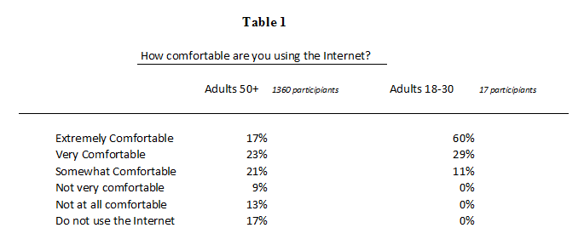

**Focus Group**

We held a focus group with 5 participants from the Dundee University User Center. We presented our idea for an travel website and held an open discussion.

During the focus group we found some minor discrepancies between user groups and the online survey statistics however this could be attributed to the selection and setting we found our small user group within and the varying experience of the participants as they were volunteers to the user center. From this we had to reevaluate some of our ideas and research findings to adjust to what was needed in the system.

We discovered that there was a desire for this system however there was concerns over who would be allowed to view information a user posted and security implications of advertising the location of users and their absence from homes that could become targets for criminals. From this we identified that usable privacy and security was at the forefront of the system.

During a focus group session we identified challenges in useable privacy and security faced using similar systems and purposed solutions to the problems. We identified that users who were presented with complex user interfaces often resorted to avoiding large portions of the system due to complexity. One user discussed his lack of understanding of the Facebook Privacy settings and not wanting others to read his posts he resorted to avoiding posting all together and used his timeline as a personal “news paper”.

We identified the learning curve was too great for some elderly users who were still gaining confidence in using the Internet, however many user’s still wanted this functionality but with multiple levels of abstraction so they could learn and build up their knowledge. Users agreed that a simple interface was beneficial for learning how to use the system with more complex options being available when confidence is gained. There is still a great need for a standard for useable privacy and security as this can vary in usability and complexity between websites.

**Research Findings**

Identifying groups of individuals for customizing privacy settings we discussed how to easily manage large groups such as friends, family, colleagues, etc. We researched if it was worth subdividing these groups into sub groups e.g. Family into intermediate family, extended family, in law, etc. Using survey findings we decided to explore how our participants wanted to share information with family as there was evidence to support that a large number of over 50’s had connections to family members through social media.

Among adults 50+ (*1360 participants)* who use social media websites there are:

* Three-quarters *connected to relatives other than**children and grandchildren* (73%).
* Three-fifths connected to children (62%).
* One-third connected to grandchildren (36%).
* Among those introduced by a family member, three-fifths (63%) said it was their child. **[4]**

Exploring our hypothesis during the focus group we discovered that sub dividing family was not necessary as most over 50’s do not want to restrict content family are available to view and most opted for a totally open privacy option when viewing and sharing with family however our participants did want to extend friends into sub groups as they wanted to share specific information with certain groups and not all friends.

**Paper Prototyping**

We produced a low fidelity paper prototype design incorporating W3 accessibility requirements (Figure 1). We created multiple versions – those that used CSS & JavaScript and those that did not to ensure we could provide the same usability across all browsers, slow connections, and to users with these settings disabled.

Improving our prototypes we focused on the functionality and accessibility by testing through iterations using cogitative walkthroughs to identify usability issues in the systems, focusing on ease of use to aid users to accomplish tasks, and making the necessary changes in the next iteration (Figure 2).

The revised design removed the image carousel, and search bar to focus on displaying a simple clean login interface that incorporated hidden content to allow a page to change dynamically to enable a user to login, register, and change a forgotten password from the same interface. Using a clear layout that directs a user to login, and in the case of new users to register was important in ensuring the system was accessible as the login was the focal point of the homepage to grant access to the information behind it.

During testing we discovered flaws in the design and revised them whilst redesigning a computer based prototype to allow quick changes to be produced. We tested the prototype again and afterwards we produced the higher fidelity model in which we could use as a basis for creating a basic wireframe to test it.

These flaws were mainly in regards to security; server and client side validation would be used to ensure only authorized individuals could access the website in the event that client side validation was disabled. With additional time this would have been expanded to allow an administrator interface to authorize new individuals as the site would have been used locally. This authorization would provide additional security to ensure that if information was wrongly shared by a user it would be to a trustworthy source.

**Wire framing**

Our survey findings, focus group research, and prototypes all influenced the initial prototype developed. A portion of the overall functionality was included to test the security and privacy settings on the most basic level – System login and content sharing. Focusing on these functions of the system it allowed us to focus on improving core functionality before trying to tackle larger problems. From our research it was important to ensure security for logging into the system could not easily be tampered with such as by disabling CSS/JavaScript support that is used for controlling the User Interface. In (Figure 3) you can see the Login page displayed with both CSS and JavaScript disabled however the functionality is still available to log in securely due to server side validation.

Whilst discussing the system during one of our focus groups we asked each participant what they would like to see in the system. A number of users agreed they wanted an easy to use system that did not contain too much content and a few users specified they would like to see the website in yellow however to quote a participant, “It had to be the right type of yellow”. Using W3 standards, information gained from paper prototyping, and decision made through cognitive walk-throughs we decided to try to meet as many requirements that participants specified whilst also adhering to W3 standards. We discovered that the yellow background participants wanted correlated to the optimal colors to improve readability for people with Dyslexia. **[5].** In figure 4 the paper prototype designs have been applied and optimal colors to improve readability have been used.

**User Testing**

During a prototype demonstration we attempted to engage users to test and evaluate the system in a natural way as the setting allowed for this. In a loud room filled with multiple demonstrations, we asked the test participants to use the system while continuously thinking out loud —simply verbalizing their thoughts as they moved through the user interface provided a quick, robust, flexible, and easy to access source of evaluation. Using the setting we had available allowed us to gain useful pieces of information from willing participants that did not feel they were being tested so they were willing to give honest feedback which was an issue during preset user testing where users felt critical advice was unwarranted. From this advice we learned that users did not need both a username and email address with the option to choose which to use to log in and instead opted for an email address they could remember so this resolved some complexity of the login and overall security of the system as now only a single set of login credentials could be valid.

**Conclusions**

Our group was surprised by the amount of interest in usable privacy and security there was amongst older generations and the lengths they would go to in order to ensure their information was not accessible by unintended individuals. From our experiences it appears that younger generations are more forthcoming about sharing information where as older generations are conserved and would rather share information directly with a person either face to face or over a telephone with the preference being for in person.

Privacy options that can be accessed with minimal effort and over multiple browsers/slow connections respond well to users who wish to access them. The use of single button privacy settings will not eradicate the time needed to configure privacy settings for large groups however it does allow for quick and efficient changes to be made such as revoking access to a group of people you do not wish to currently communicate.

Effectively choosing who you want to share information with as you are in the act of sharing it had a natural feel to it as users were making an active choice to share and decided with whom to share content. This provided some confirmation for our earlier work that suggested a default privacy setting option of only sharing with individuals a user defines manually.

Visual changes on screen such as alternating Buttons are effective in decreasing the complexity of privacy settings; however deeper complexity is needed for larger groups to initially configure a group. Click a button that alternates from Friend to Unfriend was clear and simple to use as it was a single click to unshared access to users content with that individual.

Further work is required to produce a complete system with security and privacy at its core. From our experiences implementing small pieces of functionality and testing periodically due to the continual redesign and changes that can occur. The combination of both privacy and security are tightly intertwined to HCI as single interface design flaws can either prevent users from completing a set task they wish to accomplish or can unravel the entire privacy and security compromising a users account and possibly the entire system. Security should be an integral part of the design of a system instead of an added feature towards the end. This should also be iterated and evolved with the system as large changes to functionality of the system can impact security. Although we had an initial idea the end project was very much shaped by the participants and our findings rather than a set goal.

# Acknowledgements

This document is based on the 2012 CHI Conference Student Design Competition.

# Example citations

1. Visual News

http://www.visualnews.com/2012/06/19/how-much-data-created-every-minute/

1. **Facebook Privacy Issues**

**http://news.cnet.com/8301-1009_3-57558638-83/facebook-voting-is-gone-but-privacy-issues-just-get-worse/**

1. **Employers Demand Facebook Passwords**

**http://www.forbes.com/sites/jamespoulos/2012/03/22/employers-demanding-facebook-passwords-arent-making-any-friends/**

1. **Social Media and Technology Use**

http://assets.aarp.org/rgcenter/general/socmedia.pdf.

1. Optimal Colors to Improve Readability

<http://www.w3.org/WAI/RD/2012/text-customization/r11>

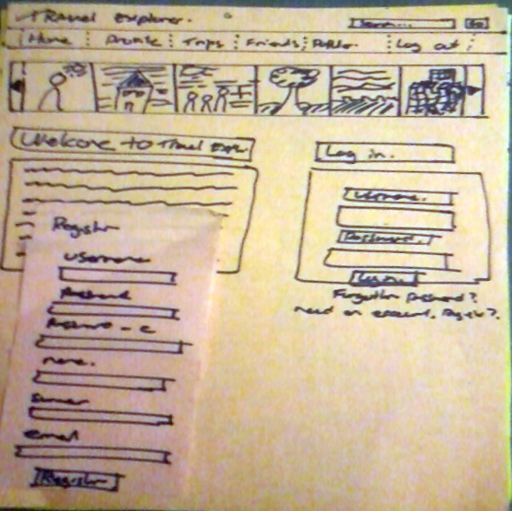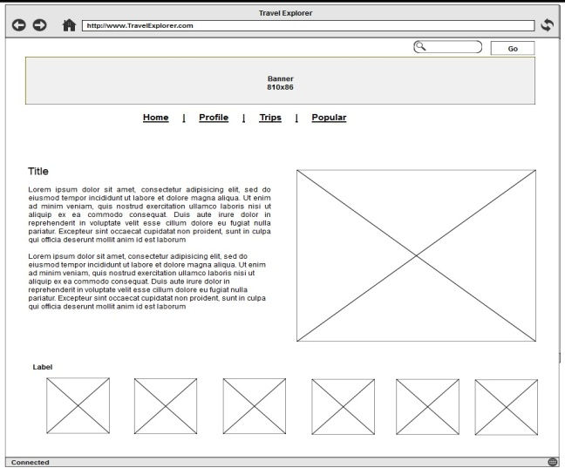

**Figure 1 – Low fidelity paper Prototype**

**An initial paper prototype design sketches on a4 yellow paper. Pink posits were used to demonstrate hidden content within the prototype that users could enable.**

**This is the home screen and the login Is contained on the right side of the page, when the users selects another form the appropriate posit was used to demonstrate this change.**

**Figure 2 – High fidelity paper prototype**

**One of the final designs before implementing the prototype. This higher fidelity prototype allowed minor changes to be made quickly and easily as the initial functionality had been prototyped and tested.**

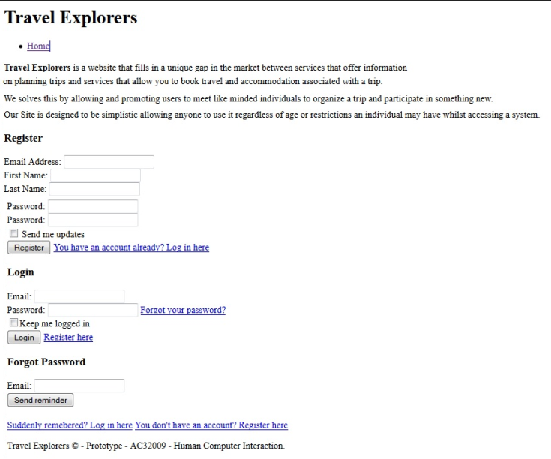

The prototype was developed in HTML prior to using CSS / JavaScript. This was to ensure that the website would be accessible and secure by using server side validation before implementing any additional functionality to improve the security and accessibility.

This initial version ensured that any users who has CSS disabled still received a secure login interface ensuring any content they posted could not be viewed by anyone who had malicious intent.

**Figure 3 – Login Screen Prototype with no CSS/JavaScript.**

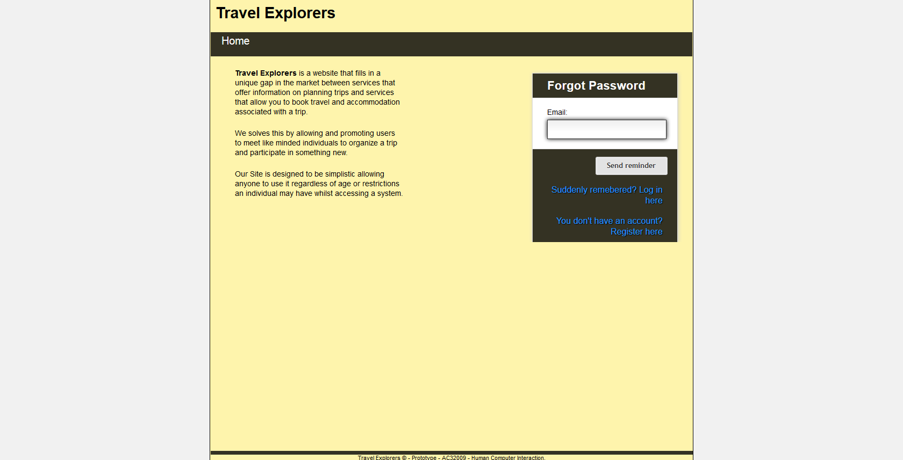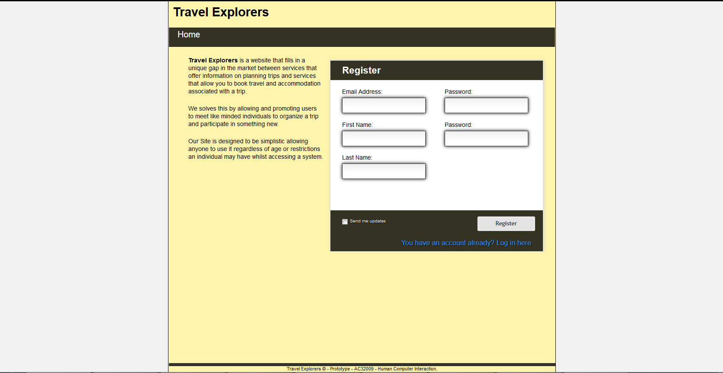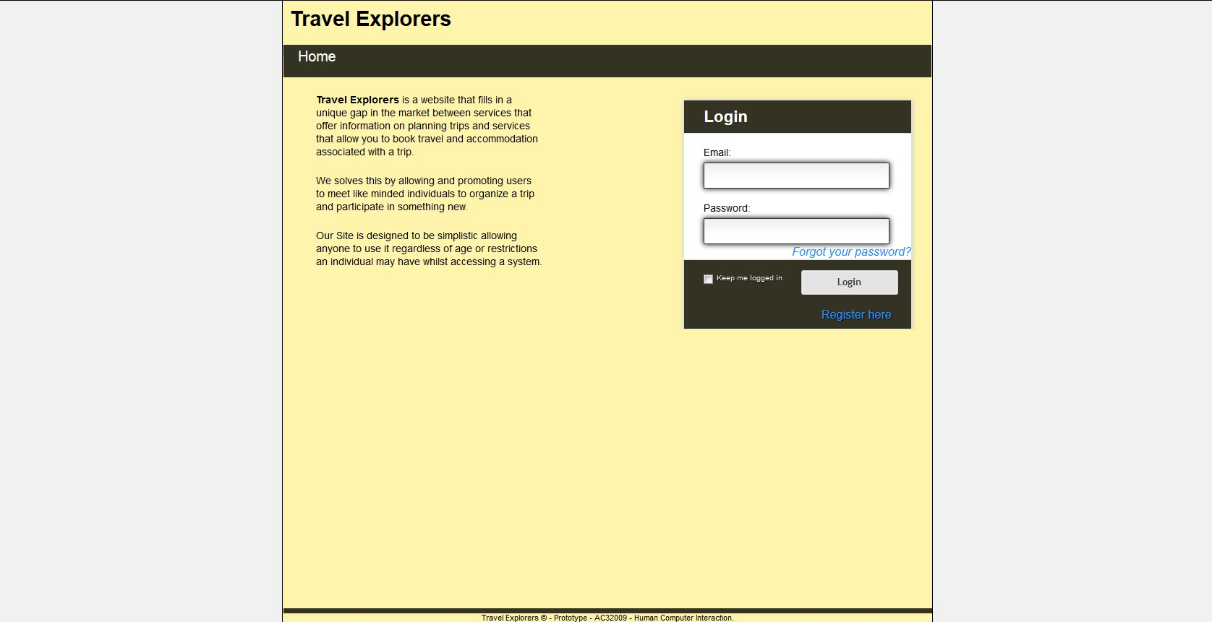

Forgotten password form appears and transitions from active form when “Forgotten your password?” is clicked disabled.

Register form appears and transitions from active form to this form when “Register Here” is clicked.

**Figure 4 – Login Screen with CSS and JavaScript.**

**In this screen shot of the prototype system it can be seen that the home screen contains all the functionality required to login to the system, recover a forgotten password, and register a new account to access the website.**